SMART on FHIR Integration Architecture

Objective
Explain how SMART on FHIR apps work and identify the technical limitations we're facing in achieving seamless Single Sign-On (SSO) from the 10g EHR system, given the absence of OIDC or SAML in its authentication server.

High-Level Architecture

Components
- 10g EHR Application: The legacy EHR system initiating SMART app launches.
- 10g Auth Server: Handles primary user authentication but lacks support for SAML or OIDC.
- Keycloak (FHIR Auth Server): Manages OAuth2 tokens and secures the HAPI FHIR server.
- SMART on FHIR App: Third-party application launched from EHR.
- HAPI FHIR Server: Backend FHIR-compliant API.

SMART App Launch Flow from 10g
- User logs into the 10g system and a session is created only in 10g.
- User clicks to launch the SMART app from within the 10g system and 10g redirects the user to the SMART app.
- SMART app queries [FHIR_BASE]/.well-known/smart-configuration to discover OAuth2 endpoints and capabilities.
- EHR (10g) launches SMART app with launch context and iss (FHIR base URL) as URL parameters.
- SMART app uses the iss value to fetch SMART configuration metadata from the FHIR server.
- SMART app redirects user to Keycloak /authorize endpoint with required OAuth2 parameters.
- Keycloak checks for existing user session; if none, prompts user to log in.
- Upon successful login, SMART app exchanges authorization code at /token endpoint for tokens.
- SMART app uses the access_token in the Authorization header to call FHIR APIs.
- FHIR server validates the token and responds with requested patient/resource data.
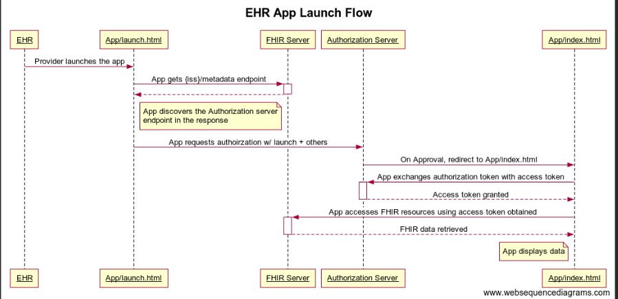

Detailed SMART on FHIR Workflow

1. SMART Discovery Phase
- The SMART app queries the .well-known/smart-configuration endpoint:
- GET [FHIR_BASE]/.well-known/smart-configuration
- This returns a JSON object containing:
  - authorization_endpoint
  - token_endpoint
  - capabilities
  - scopes_supported
  - response_types_supported

2. Launch Parameters
- When the SMART app is launched from the EHR (10g), it receives:
  - launch: a context identifier from the EHR
  - iss: the FHIR server base URL
Example Launch URL from 10g:
https://smart-app.com/launch?launch=eyJhcHBsaWNhdGlvbiI6ICJzbWFydCIsICJjb250ZXh0IjogInBhdGllbnQifQ&iss=https://fhirserver.com/fhir

3. App Resolves Metadata
- The SMART App uses iss to call:
- GET [iss]/.well-known/smart-configuration
- It retrieves endpoints required for authorization.

4. Authorization Request
- SMART app redirects to Keycloak /authorize endpoint with parameters:
- GET /authorize?
- response_type=code
- &client_id=smart-client
- &redirect_uri=https://smart-app.com/callback
- &scope=openid fhirUser launch/patient offline_access
- &state=xyz
- &aud=[iss]
- &launch=[launch token]
- &prompt=select_account

5. Authentication
- Keycloak checks if a session exists:
  - If yes → proceed
  - If no → user sees login screen

6. Token Exchange
- SMART App sends authorization code to /token endpoint:
- Keycloak returns access token, refresh token, ID token.

7. FHIR API Access
- SMART app sends access token in Authorization header:
- GET /Patient
- Authorization: Bearer <access_token>
- The FHIR server validates token and returns data.

Challenges in Enabling SSO Without OIDC/SAML Support

1. Token Exchange Breaks SMART on FHIR Standards
- If the 10g server obtains a Keycloak token via token exchange and tries to pass it to the SMART app directly, it violates the SMART on FHIR standard, which expects the app to follow the full OAuth2 authorization code flow.
- SMART apps are designed to receive tokens only from the /authorize → /token flow, not via direct injection or pre-acquired tokens.

2. Cannot Inject Keycloak Session into Browser
- 10g server cannot create a browser session in Keycloak, since session cookies are HTTP-only and domain-restricted, and cannot be written from one application to another via JavaScript or APIs.
- Without a valid Keycloak session in the browser, any redirect to Keycloak’s /authorize endpoint will always prompt login, even if the user is authenticated in 10g.

3. No Seamless Redirect Possible
- Keycloak requires a front-channel login interaction to establish its own session and issue authorization codes.
- Since 10g cannot silently log the user into Keycloak, the user will always face a login prompt during SMART app launch.

4. Cross-Origin Cookie Restrictions
- Keycloak cookies are scoped to its domain, and browsers block setting these cookies from another domain (like 10g) due to SameSite and CORS policies.
- Attempting to forward or mirror session cookies is unreliable and not secure, especially in OAuth2-compliant flows.

5. Security and Compliance Issues
- Injecting tokens or cookies across systems bypasses standard security flows, leading to audit, traceability, and revocation challenges.
- It could compromise trust boundaries between systems and affect conformance with healthcare standards like SMART on FHIR and HIPAA.

SMART App Seamless Login via 10g Auth Server (with OIDC/SAML Support)
If the 10g authentication server supports OIDC or SAML, it can be configured as an Identity Provider (IdP) in Keycloak. This setup enables true Single Sign-On (SSO) and ensures a smooth authentication experience during SMART on FHIR app launches.

How It Works:
- SMART App Initiates Authorization:
The SMART app redirects the user to the Keycloak /authorize endpoint as part of the OAuth2 flow.
- Keycloak Redirects to 10g Auth Server:
Since 10g is configured as an IdP in Keycloak, Keycloak delegates the login to 10g via OIDC or SAML.
- Existing Session is Reused:
If the user already has an active session in the 10g auth server, the 10g server automatically authenticates the user without prompting for credentials.
- User is Logged In Automatically:
The 10g auth server redirects back to Keycloak with a successful authentication response, and Keycloak then completes the flow, issuing the token to the SMART app.

